I phone -set-up

- Select the REVO MOBILE icon
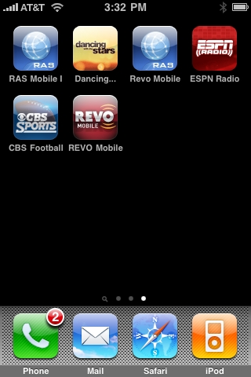

- Select settings.

- After you select the settings buttons click on site list
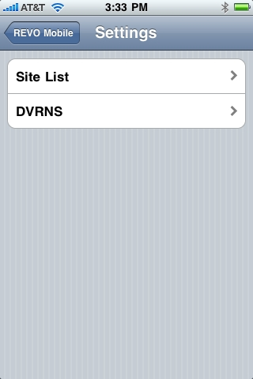

- 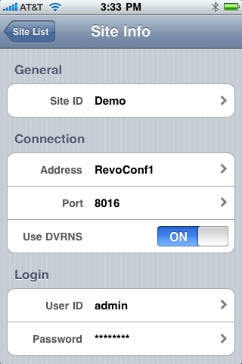

- Set the site id , which is just a description of the site where the DVR is ( ex: work: business: home)

- 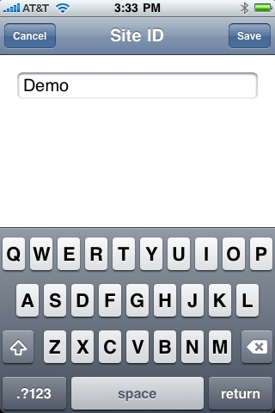

- Set the address with either the name of the Dvr or ip address. ( EX: RevoConf1)

- 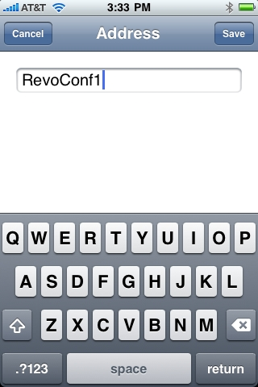

- Port should always be 8016 which is the watch port.

- Use DVRNS should always be on if you is using the name of the DVR to pull up your cameras.

- Set the user id to admin always lower case.

- 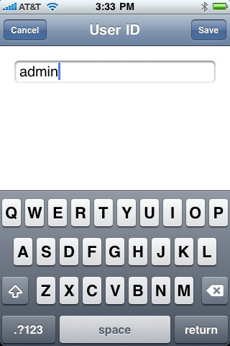

- Set the password, which is the exact same password to your DVR, IF YOU HAVE ONE!!

- 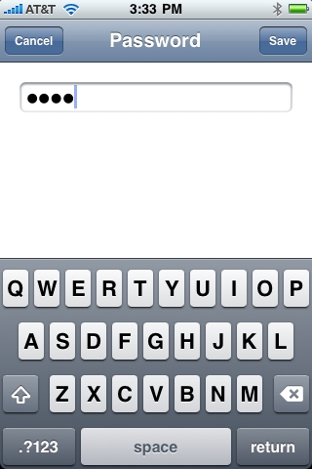

- Next go back to the site list tab and select the site you created.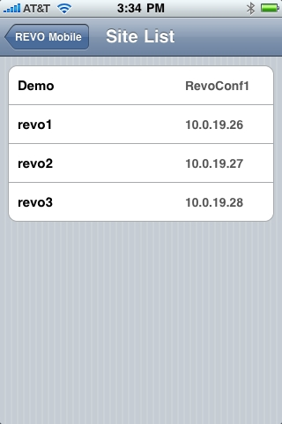

- Select the connect button. And your final outcome should resemble something like this.
- 