Model#: REVDN800E-1
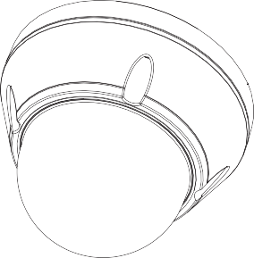

WDR Super High
Resolution Day & Night
Camera

FCC COMPLIANCE STATEMENT

This device complies with Part 15 of the FCC Rules. Operation is subject to the following two conditions: (1) this device may not cause harmful interference, and (2) this device must accept any interference received, including interference that may cause undesired operation.

FCC INFORMATION : This equipment has been tested and found to comply with the limits for a Class A digital device, pursuant to Part 15 of the FCC Rules. These limits are designed to provide reasonable protection against harmful interference when the equipment is operated in a commercial environment. This equipment generates, uses, and can radiate radio frequency energy and, if not installed and used in accordance with the instruction manual, may cause harmful interference to radio communications. Operation of this equipment in a residential area is likely to cause harmful interference in which case the user will be required to correct the interference at his own expense.

CAUTION : Changes or modifications not expressly approved by the party responsible for compliance could void the user’s authority to operate the equipment.

CE COMPLIANCE STATEMENT

WARNING : This is a Class A poduct. In a domestic environment this product may cause radio interference in which case the user may be required to take adequate measures.

IMPORTANT SAFETY INSTRUCTIONS

- Read these instructions.
- Keep these instructions.
- Heed all warnings.
- Follow all instructions.
5.. Do not block any ventilat ion openings. Install in accord ance with the manufacturer`s instructions.
- Do not install near any heat sources such as radiators, heat registers, stoves, or other apparatus (including amplifiers) that produce heat.
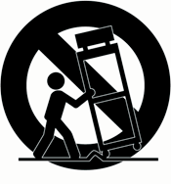

- Only use attachments/accessories specified by the manufacturer.
- Use only with the ca rt, stand, tripod, bracket, or table specified by the manufacturer, or sold with the apparatus. When a cart is used, use caution when moving the cart/ apparatus combination to avoid injury from tip-over.
9. CAUTION - THESE SERVICING IN STRUCTIONS ARE FOR USE BY QUALIFIED SERVICE PERSONNEL ONLY. TO REDUCE THE RISK OF ELECTRIC SHOCK DO NOT PERFORM ANY SERVICING OTHER THAN THAT CONTAINED IN THE OPERATING INSTRUCTIONS UNLESS YOU ARE QUALIFIED TO DO SO.
10. Use satisfy clause 2.5 of IEC60950-1/UL 60950-1 or Certified/Listed Class 2 power source only.
11. Indoor use only.

EXPLANATION OF GRAPHICAL SYMBOLS

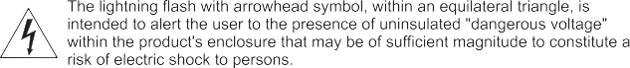

LIMITATION OF LIABILITY
THE INFORMATION IN THIS PUBLICATION IS BELIEVED TO BE ACCURATE IN ALL RESPECTS, HOWEVER, WE CANNOT ASSUME RESPONSIBILITY FOR ANY CONSEQUENCES RESULTING FROM THE USE THEREOF. THE INFORMATION CONTAINED HEREIN IS SUBJECT TO CHANGE WITHOUT NOTICE. REVISIONS OR NEW EDITIONS TO THIS PUBLICATION MAY BE ISSUED TO INCORPORATE SUCH CHANGES

TABLE OF CONTENTS

INTRODUCTION 5

CONNECTIONS 6 BASE INSTALLATION 7 MENU MAP 8 SPECIFICATIONS 19 EXTERNAL DIMENSION 20

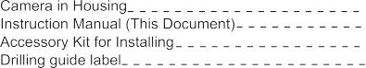

The camera provides a high-quality image using SONY Wide Dynamic 1/3” Super-HADII PS 960H CCD and digital signal processing LSI chips.

1/3" Super-HADII PS 960H CCD
Super high-resolution of 800TV lines
Wide Dynamic Range (~x512) -Double shutter+ATR-EX2
Auto Electronic Shutter [1/50 ~ 1/100,000] and manual electronic shutter modes [1/50 ~ 1/10,000]
0.1 lux(Colour), 0.01 lux(B/W), 0.001 lux(Slow-Shutter) @ F1.4 Sensitivity Digital Noise Reduction- 2D,3D
Day & Night(Auto, Day, Night)
Sens-Up (~x256)
Various Detection Methods (zone detection, motion trace, face trace, mine area, absent detection, cross object counting, entrance counting)
Intelligent scene recognition - Provide the best image automatically for every scene Mechanical iris auto adjustment
Privacy Mask or Mosaic (MAX. 15 area /4-point polygonal/transparency) E-Zoom
White pixel detection and compensation Digital Effect-FLIP (H/V reverse, inverse)
Defog(Auto) - Detects foggy condition automatically and provides high contrast picture
IR Optimizer
Coaxial communication (Coaxitron by Pelco)
RS-485 Remote camera control(Pelco-D)-Option
Support Line-Lock external synchronization (Line lock) -Option Operates in 12VDC or 24VAC-Option

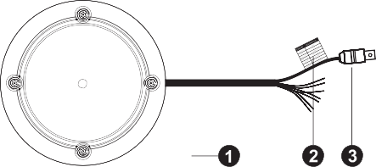

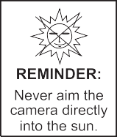

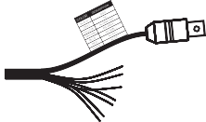
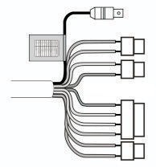

<Connector Option>
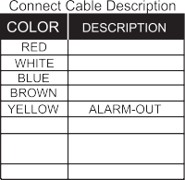

AC24V/DC12V
AC24V/DC12V RS 485 (-)
RS 485(+)
GRAY
BLACK SKY BLUE PINK
DN EXT-IN
GND
UTP+(Option) UTP-(Option)

- Lens : Allows a wide area to be monitored.

Color Lead Wire & Color Display Label 2-1. External Day/Night Control(Option)
Select Day/Night mode using external equipment, by connecting control lines to the appropriate terminals.
DAY&NIGHT EXTERNAL INPUT
Switches the cameras D/N mode to either Day or Night based on the input status. Refer to the diagram below. The cameras CNTL SIGNAL of D/N AUTO mode must be set to EXT2 for this to function.
  - Open contact: DAY
Black | GND
Gray | DAY&NIGHT INPUT

2-2. Alarm Out -Open Collector (5V/10mA)
- Close contact: NIGHT

Motion detection signals are output through this port. Active state is Low(GND). Normal : Open Collector, ALARM : Low(GND)

2-3. Power Input Terminal
RED & WHITE : These terminals accept 24V AC or 12V DC. When using 12V DC it is recommended to use a DC power supply that can support an inrush current of 0.55A
2-4. Camera Control BROWN : RS 485+ BLUE : RS 485-

2-5. UTP(Option)
Video signal through out the UTP cable (SKY BLUE(+) & PINK(-))
- Video : BNC connector used to connect the camera to a monitor, swither, etc.

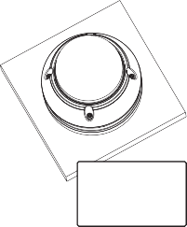

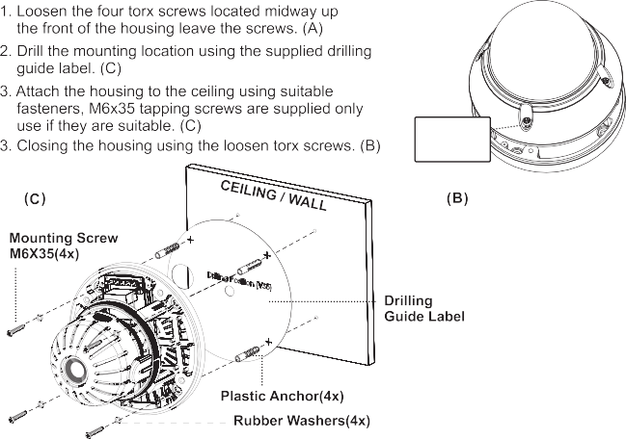

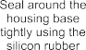

(A)
Torx screws
M5x10 (4x)

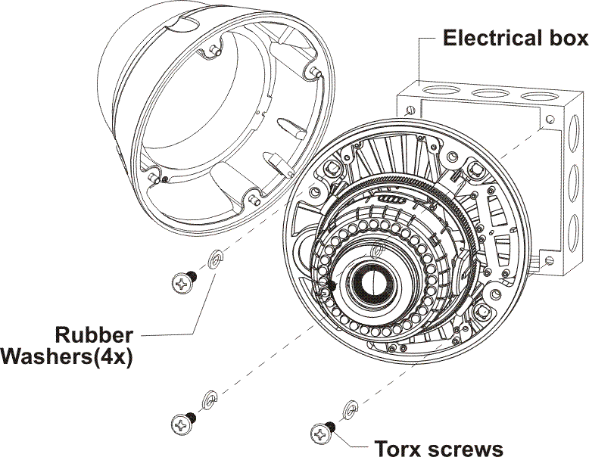
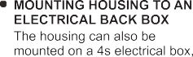

MENU MAP

SETUP MENU
1/ 2
SCENE SELECT PICT ADJUST EZOOM
DIS
PRIVACY MASK MOTION DET SYS SETTING EXIT

SCENE SELECT
CUSTOM FULL AUTO INDOOR OUTDOOR BACKLIGHT ITS

PICTURE ADJUST
BRIGHTNESS CONTRAST SHARPNESS HUE
COLOR GAIN

MAG PAN TILT

EZOOM

RETURN RETURN

ADVANCED MENU
1/ 2
SHUTTER/AGC WHITE BAL
HLC/BLC WDR/ATR-EX
DNR DAY/NIGHT
IR OPTIMIZER RETURN

SHUTTER/AGC
AUTO MANUAL FIX

WHITE BAL
ATW PUSH USER1 USER2 MANUAL
PUSH LOCK

WDR/ATR-EX
OFF ATR-EX WDR

DAY/NIGHT
AUTO DAY NIGHT

AUTO SETUP
AE LEVEL AGC MAX SENS UP
ATW SETUP
SPEED DELAY CNT ATW FLAME
ENVIRONMENT
WDR SETUP
CONTRAST CLEAR FACE
D/N AUTO SETUP
BURST
CNTL SIGNAL DELAY CNT DAY->NIGHT NIGHT->DAY

RETURN

RETURN

RETURN

RETURN

IR OPTIMIZER SETUP
MODE IR AREA LEVEL IR LED
COLOR NIGHT

TOP

IR AREA

IR LED
DAY/NIGHT

IR SHADE COMP SETUP
PATTERN

IR SHADE COMP
RETURN
BOTTOM LEFT RIGHT WEGHT
OFF FIX
POSH POSV LEVEL

RETURN RETURN

MENU MAP

ADVANCED MENU
2/ 2
LENS SHD COMP DEFOG
FLK LESS ANTI CR
RETURN
LENS SHADE
COMP SETUP
PATTERN POSH POSV
DEFOG SETUP
LEVEL
FLK LESS
AUTO OFF ON
ANTI CR
AUTO OFF ON
RETURN
RETURN

SETUP MENU
1/ 2
SCENE SELECT PICT ADJUST EZOOM
DIS
PRIVACY MASK MOTION DET SYS SETTING EXIT
MOTION DET
DETECT SENSE INTERVAL BLOCK DISP MASK AREA MONITOR AREA
DIS
OFF
ON
PRIVACY MASK
AREA SEL DISPLY POSITION COLOR TRANSP MOSAIC
RETURN
RETURN
SYS SETTING
SYNC MODE LENS
FLIP LCD/CRT
COMMUNICATION CAMERA ID ENTRANCE RETURN
MONITOR AREA
AREA SEL AREA MODE TOP BOTTOM LEFT
RIGHT
AUTO IRIS SETUP
MODE ADJUST SPEED
FLIP
OFF
V H
HV
COMMUNICATION
PROTOCOL ADDRESS BAUDRATE DATABIT PARITY STOPBIT
RETURN
RETURN
RETURN
RETURN

MENU MAP

SETUP MENU
2/ 2
LANGUAGE VERSION MAINTENANCE EXIT

LANGUAGE
ENGLISH ESPANOL PYCCKNN PORTUGUES DEUTSCH FRANCAIS
日本語
RETURN

MAINTENANCE
W.PIX MASK CAMERA RESET

RETURN

AUTO COMP
LEVEL1 LEVEL2 AUTO

MANUAL COMP
REGISTRATION REG.POINT CUSOR COLOR BLINK REG.NUMBER
W.PIX MASK
AUTO
DATA CLEAR MANUAL

RETURN
RETURN

<SETUP MENU>

Scene Select function
The six modes can be selected.
CUSTOM /FULL AUTO / INDOOR / OUTDOOR / BACK LIGHT / ITS

CUSTOM
This mode turns off the auto scene recognition. All functions can be set and adjusted manually

FULL AUTO
This mode supports various shooting scenes. It is not specialized to any particular scene, so it allows average shooting in any situation.

INDOOR
This mode is specialized to indoor scenes, such as indoor shop surveillance. It allows natural shooting with high contrast.

OUTDOOR
This mode is specialized to outdoor scenes, such as road surveillance. It features high contrast and resolution, and allows shooting with high visibility even in foggy outdoor conditions.

BACKLIGHT
This mode is specialized to scenes that mix indoor and outdoor conditions, such as entranceway surveillance.
It allows shooting with high visibility and a high dynamic range, even under backlighting conditions.

ITS
This mode is specialized to scenes where moving subjects enter the picture, such as traffic surveillance scenes. It allows high-resolution shooting of moving subjects with low blur.

Scene Select function
This Camera system provide functions that enable users to easily adjust the image quality to suit the image output device used.
Brightness - Adjusts the brightness
Contrast - Adjusts the image contrast (light and shade differences).
Sharpness - Adjusts the apparent resolution
Hue - Adjusts the hue
Color Gain - Adjusts the intensity (brilliance) of the colors

- EZOOM (Electronic Zoom) EZoom - ON / OFF
MAG - Magnification rate = ZOOM (0~255)
PAN - Horizontal position settings
TILT -Vertical position settings

DIS (Digital Image Stabilizer)
Digital Image Stabilizer (DIS) function internally detects shaking of the image due to camera shaking, and performs digital compensation processing inside the DSP to suppress this shaking and stabilize the image output.

PRIVACY MASK
The mask function hides one or more areas which the user does not want to be displayed on the screen. This SET is capable of outputting 15 masks to the display. Each of these 15 masks can be set with its own display area, color, darkness and mosaic processing.
AREA SEL - Select mask area (1-15). DISPLAY - Mask to ON or OFF POSITION
COLOR - Sets the color blend:
RED/ GREEN/ BLUE/ YELLOW/ CYAN/ MAGENTA/ WHITE/ BLACK
TRANSP - Sets the brightness blend ratio: 0%, /50%/75%/100%
MOSAIC - Sets the mosaic to ON or OFF.

MOTION DET (Motion Detection)
By using the motion detection function, it is possible to create surveillance cameras which are capable of detecting moving objects. The motion detection function identifies motion and outputs motion information when the difference in brightness exceeds a specific level between frames(2VD).

DETECT SENSE
Sets the motion detection threshold.

INTERVAL
Sets the MD detection interval. Subjects are detected when an interval exceeding the set number of fields has elapsed from the previous motion detection.

BLOCK DISP
Motion detection result frame display selection
Outputs the results of the motion detected in each block

MASK AREA
MD (Motion Detection) setting menu, for setting the no-detection area.
The active point (MASK AREA 1~96) is displayed. Move the point with 4-arrow keys. Press [ENTER] key is to finish edit point. (No-detection area)

MONITOR AREA
Sets the position of the monitoring frames in pixel or line increments

SYS SETTING
7-1. SYNC MODE (OPTION)
External synchronization is a function with synchronization of the phase between an output video signal and an external reference signal. Use line lock mode to minimize color rolling.

INT
In this mode, synchronization is not implemented with a multiple number of cameras.

LL
In this mode, PLL is used to synchronize the vertical sync signal with the AC power supply with a power line frequency of 60 Hz (for the NTSC format) or 50 Hz (for the PAL format).
PHASE -External synchronization phase adjustment.(LL)
Note: LLC can only be used when AC power is used.
LL of DC power input state, IC operates internally(INT).

7-2. LENS
Set the lens type
AUTO Select the Lens DC Iris type
Manual Select the Lens Manual type

7-2-1. MODE
AUTO This mode controls the iris in accordance with the subject brightness.
OPEN This mode fully opens the iris.
CLOSE This mode fully closes the iris.

7-2-2. ADJUST
When performing the automatic mechanical iris adjustments, the convergence speed which is suitable for the lens installed is calculated, Shoot a high-brightness subject which will make the brightness of the whole screen uniform.
-Check that the shooting conditions are sufficiently bright and stable.

7-2-3. SPEED
Sets the convergence speed.

7-3. FLIP
Select digital Flip / Rotate state
Off / V(Top / bottom reversal) / H(Left / right reversal) / HV(Rotation by 180 degrees)

7-4. LCD / CRT
Seclect Monitor mode.

7-5. COMMUNICATION (OPTION)
Communication using the RS-485 format.(Option) Press the Enter button to access the Communication. Protocol - RS-485 protocol. (PELCO-D)
ADDRESS - Select the camera ID. (001 - 255)
Baud Rate - Select serial communication speed. (2400 / 4800 / 9600 / 19200)
Note. Key of Keyboard Controller
MENU Joystick Handle turn clockwise , ZOOM TELE ENTER Joystick Handle turn clockwise, IRIS CLOSE OSD Cursor Movement Joystick Up / Down / Left / Right

7-6. CAMERA ID
CAMERA ID SETUP.
CAMERA ID SETUP
CAMERA ID

ABCDEFGHIJKLMNOPQRSTUVWXYZ 0123456789`~!@#$%^&*()-_=+<,>.?/;:’”
CLR POS

RETURN

Sets the camera ID to ON or OFF. A title of 64 Characters per line can be applied.
Use the joystick to navigate the cursor.
Pushing centrally on the joystick will allow selection of that character.
The arrows at the bottom allow you to move the cursor without changing the character.

CLR
Inserts a space

POS
Allows you adjust the location of the camera ID title display. (if you move too much right side or down, it might lose ID on the screen)

EXIT-MENU
SAVE Save the settings (settings are saved)
NOT SAVE Exit
Menu without saving SAVE : Exit menu without saving.
CANCEL Changes (restore settings to those selected when the menu was displayed)
BACK Return to previous menu
RETURN Return to page on the hierarchical level immediately before.

LANGUAGE
LANGUAGE select between:
English, Spanish, Russian, Portuguese, German, French, Japanese.

VERSION
Camera version information.

MAINTENANCE W.PIX MASK
White pixel compensation menu. The white pixel detection and compensation function can
automatically detect and compensate up to 64 white pixels.(Static detection)

AUTO
This mode performs the optimal operation for detecting white pixels, and automatically detects the white pixels of CCD image sensors.

LEVEL1 - Normal Defect
The threshold adjustment of the white pixel detection
LEVEL2 - Large Defect
The threshold adjustment of the very large white pixel detection
AUTO Press Enter button to turn White Pixel Compensation mode Start.
RUN Press Enter button to start White Pixel Compensation start.
RUNNING Process to find white pixel.
SBC SUCCESS Process ended.

MANUAL

- REGISTRATION
Manual white pixel defect information registration
  - Press the Enter button to turn White pixel compensation position marker display.
  - Use the Arrow buttons align the marker with the position of the white pixel.
  - Press the Enter button to exit and Press the EXIT button to save.
Note : In manual detection mode, the detection data is always treated as a very large white pixel. Up to 64 white pixel compensation.

NEXT REGISTRATION
Continue with manual white pixel compensation settings

REG.POINT
Selects whether to display the registered White or Black pixels

CURSOR COLOR
Cursor color during manual defect registration

BLINK
Cursor display blinking during manual defect registration

REG.NUMBER
Registered white pixel defect count display

DATA CLEAR
Initializes the white pixel compensation information
Select erasing white pixel function to press Enter button (YES)

<ADVANCED MENU>

SHUTTER / AGC
AEME (Auto Exposure / Manual Exposure) selection, shutter / AGC
This type of control adjusts the exposure amount using the shutter speed.

12-1. AUTO
Exposure control is performed automatically.

AE LEVEL (Auto Exposure Lebel)
AE performs exposure control so that the OPD output level (evaluation value) is the target brightness level (AE reference level). This control is called AE gain control.

AGC MAX
Maximum gain setting item in shutter priority mode AGC (Auto Gain Control)
This type of control adjusts the exposure amount during CCD signal input by applying AFE gain

SENS UP (Slow Shutter)
Low-brightness sensitivity enhancement menu Select maximum Slow-Shutter (AUTO and Off)

12-2. MANUAL
Exposure control is performed manually.

12-3. FIX
Exposure control is stopped. AE does not track even if the subject brightness changes.

WHITE BAL
Compensates for deviations in the white colour caused by changes in the colour temperature of the light source so that the colours are reproduced correctly.

ATW - ATW mode (1800ºK ~10500ºK)
Performs indoor / outdoor identification, estimates the light source, and performs WB control automatically.

Push (Full pull-in)
This control is resistant to the effects of deeply colored subjects. The PUSH function performs WB control automatically regardless of the indoor/outdoor and light source conditions. Compensation may be performed incorrectly since this control is easily affected by deeply colored subjects.

USER1
The USER1 functions set the WB gain in accordance with preset values. (3200ºK) WB control does not track even if the subject color temperature changes.
Adjust red or blue gain.
R(R-GAIN):Adjust R-GAIN value (0-255) B(B-GAIN):Adjust B-GAIN value (0-255)

USER2
The USER2 functions set the WB gain in accordance with preset values. (5800ºK) WB control does not track even if the subject color temperature changes.
Adjust red or blue gain.
R(R-GAIN):Adjust R-GAIN value (0-255) B(B-GAIN):Adjust B-GAIN value (0-255)

MANUAL
MWB allows WB control to be performed manually following the black body radiation curve. The configurable color temperature setting range is 1500K to 15000K. The setting can be performed in 64 steps.

PUSH LOCK
Holds the all pull-in frame The PUSH LOCK function first transfers to PUSH mode and performs pull-in operation, and then transfers to HOLD mode when pull-in is complete.

HLC / BLC
HLC (Highlight Compensation)
HLC luminance signal processing is a function that suppresses or masks the luminance signal. It reduces the load on watchers' eyes and enhances visibility impaired by strong light sources or other factors by performing output while suppressing the brightness of high-brightness areas.

CLIP LEVEL HLC mask level

BLC (Backlight Compensation)
The BLC function provides compensation by increasing the brightness of the overall screen so that subjects being shot with a loss of dark detail due to backlight will have just the right brightness level.

15.WDR/ATR-EX
CONTRAST(LOW/MID/HIGH) Contrast adjustment gain
CLEAR FACE(OFF/ LOW/MID/HIGH) High-frequency component adjustment gain

ATR-EX(Extended)
The ATR function provides gradation compensation with the aim of improving visibility. It compensates to the optimum gradation on the basis of the luminance information.
This function compresses the dynamic range while storing the contrast component of the subject.

WDR(Wide Dynamic Range)-Option
When users shoot subjects which exceed the dynamic range of the CCD image sensor, parts of the subjects suffer from loss of dark detail (blocked up shadows) or overexposure (blown out highlights). The Wide Dynamic Range (WDR) function ensures that when images are shot under conditions such as these, images free from loss of dark detail or overexposure are output.

DNR
Used to reduce image noise in order to improve the image quality of the camera.
It reduces the noise which is generated under low-light conditions and other high-gain states.
LEVEL Adjusts the NR (3D+2D) strength (0~6)

DAY/NIGHT 17-1 AUTO
Camera automatically switches between Day&Night modes according to the D>N & N>D levels.
BURST : Select B/W Burst On/Off

CNTL SIGNAL
Selection of brightness reference for identifying Day/Night Control Signal.
INT ILM levels
EXT1 external sensor inverting.
EXT2 external sensor non-inverting.
Ext : Camera switches between Day & Night modes according to the D/N EXT input. (ILM level or GPI Cable)

Delay CNT : Adjust the judgment time for the transition between the Day and Night. (0-255).
DAY>NIGHT Level : Select switching level Day to Night (0-255). NIGHT>DAY Level : Select switching level Night to Day (0-255) Day : Camera stays in Day mode (Color)
Night : Camera stays in Night mode (B/W)
- IR OPTIMIZER (OPTION)
If, when the Night operation mode of the Day/Night function is established, the mode is used together with an external infrared LED light source, excessive front lighting may be generated, resulting in overexposure.

18-1. IR OPTIMIZER SETUP
MODE(IR Model only)
IR optimizer photometry mode selection

IR AREA
IR optimizer judgment area setting menu in spot photometry mode

LEVEL
IR optimizer intensity(0~12)

IR LED(IR Model only)
OFF LED light level is LOW
FIX Adjust LED light level (0~255).
DAY/NIGHT LED light level determinate AE reference level

COLOR NIGHT
The Color Night Mode (CNM) function allows images to be taken as color images even with infrared LED floodlighting under low-brightness conditions.
This Camera System feature a function that achieves both improved sensitivity and the ability to reproduce colors under infrared LED floodlighting using signal processing that separates the infrared LED light components from the images taken and extracts the original colors of the subject. This function takes effect during Night operations.
COLOR GAIN LOW/MID/HIGH

IR SHADE COMP (IR Model only)
The IR-SHD function compensates for observable events in which the light passing through the lens is imaged non-uniformly.
Shading function ON/OFF selection

PATTERN
Selects the shape of the ellipse (HIGH/MID/LOW)

POSH / POSV
Use the center coordinate settings to adjust the shading compensation to the center position of the optical axis.

LEVEL
The compensation level can be set to low, medium or high for basic shading compensation data.

LENS SHD COMP
The LENS SHD function compensates the lens is imaged non-uniformly.

PATTERN
Selects the shape of the ellipse (HIGH/MID/LOW)

POSH / POSV
Use the center coordinate settings to adjust the shading compensation to the center position of the optical axis.

DEFOG
Defoging function ON/OFF selection. The defog function raises the contrast to improve visibility. For example, in foggy conditions, contrast is reduced and visibility drops. In such cases, enabling the defog function prevents a drop in contrast. In addition to compensating for contrast, compensation is also made for the saturation, edges, and 3D-NR moving body identification threshold. The defog compensation strength can be set to three levels (Low, Mid, High) using the Auto function.

FLK LESS
Flickerless function ON/OFF selection

MODE
GAIN CNTL Selects gain modulation ON.
SHUTTER FIX Selects flickerless shutter fix ON.

ANTI CR (Anti color-rolling)
Anti color-rolling mode is valid when the AEME parameter is set to AE. When the parameter is set to HOLD, the status of the previous field is maintained.
Users can select from the following anti color-rolling modes.
AUTO Anti color-rolling is automatically detect and compensate
ON Anti color-rolling is always compensate
OFF Anti color-rolling is not compensate
When the Auto anti color-rolling mode is selected, then the auto flickerless mode is turned on at the same time.

*Note Coaxial Communication (32 Bit)
Recommendation Controller can communicate with camera through the BNC port.

Recommendation controller
Coaxial Remote Controller : RM-1000

SPECIFICATIONS

(Option) AC24V / DC12V - 180mA(2.2W)
DC12V - 170mA(2.1W)
1/3" Super-HADII PS 960H CCD

Effective pixels
1028(H)x508(V)
976(H)x494(V)
1028(H)x596(V)
976(H)x582(V)

0.01
/ Line Lock(Option) 800TVL
, 0.001Lux(Slow-shutter)
/ UTP(Option)

Tact Switch, Coaxial COMM(32BIT),RS485(Pelco D)
Lens DC / MANUAL
Scene Select CUSTOM / FULL AUTO / INDOOR / OUTDOOR / BACKLIGHT / ITS
White Balance ATW/ PUSH/ USER1/ USER2/ MANUAL/ PUSH LOCK
6~44.8DB

Shutter Speed
1/60-1/100,000 sec.(Auto)
1/50-1/100,000 sec.(Auto)

BLC OFF / HLC / BLC

Camera Title
Alpha Numeric

DNR 2DNR, 3DNR : Gain Adjust
Auto / Day / Night
IR Optimizer OFF / ON
Color Night OFF / ON
Privacy zone Max 15 (Tilt, Colour, Transparency, Mosaic)
Effect V-Flip / Mirror / Rotation / Nega&Posi / Freeze / Sharpness Sens-up OFF / AUTO
Sharpness 0~15 steps

WDR
E-Zoom Bad Pixel
MOTION
WDR/ATR-EX (LOW/MID/HIGH) OFF / 0 ~ x255(E-Zoom) / PAN/TILT
AUTO/MANUAL/Done (Max 64 point), Detected pixel display
Detect Sense/Interval/Block DISP/Mask Area/Monitor Area

Auto-color-roling Auto / ON / OFF

Lens
LANGUAGE

.
English, Spanish., Russian, Portuguese, German, French, Japanese(OPTION)
2P WIRE
BNC connector or UTP OUT(Option) f=2.8~12mm F1.4~360 Varifocal, ICR (D&N)
Fixed Mount

146 x 114mm(H)
700g

AC24V / DC12V - 440mA(5.2W - IR LED ON) DC12V - 430mA(5.1W - IR LED ON)
IR

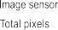

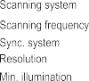

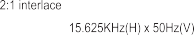

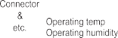

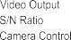

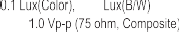

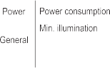

Etc.

Weight
30
30M
715g

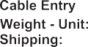

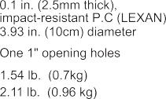

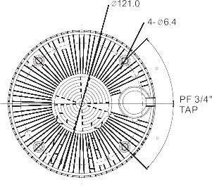

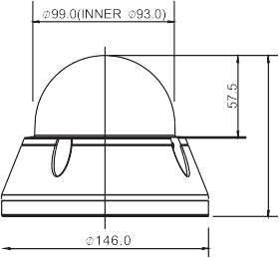

114

50303714B

